**Experiment: 7**

Date: 11 /4/2022 Section: A24

Name: Utkarsh Trivedi

Branch: CSE Roll: 21053223

**CHLORIDE ESTIMATION**

AIM OF THE EXPERIMENT : To determine the chloride ion (Cl¯) present in a given water sample by argentometric method by using N/100 AgNO₃ solution.

APPARATUS REQUIRED :

1. Burette

2. Pipette

3. Conical flask

4. Beaker

CHEMICALS REQUIRED :

1Standard AgNO3 solution

2.K2CrO4 solution

3. Water sample

PRINCIPLE :

Chlorides are present in water usually as NaCl, MgCl2, and CaCl2. Although chlorides are not harmful, but their concentration over 200 ppm, imparts a peculiar taste to water, thus rendering the water unacceptable for drinking purpose.

When AgNO3 solution is released from the burette to the water sample containing Cl-, first Ag+ reacts with Cl- and forms a yellowish white precipitate of AgCl. After completing reaction with Cl-, with the addition of one extra drop of AgNO3 imparts a red colour to the solution due to formation of Ag2CrO4.

CHEMICAL REACTION :

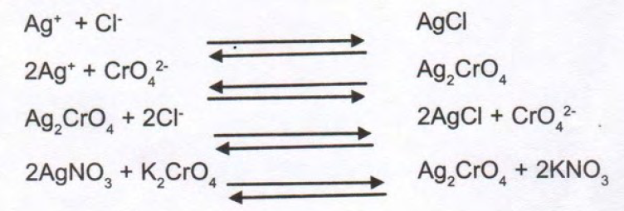

1.

OBSERVATION TABLE

|  |  |  |  |  |  |
| --- | --- | --- | --- | --- | --- |
| No. of Obs. | Vol. of water sample (ml) | Burette Reading (ml) | | | Remark |
| Initial | Final | Difference |
| 1 | 25 | 0 | 5 | 5 | Rough |
| 2 | 25 | 5 | 9.9 | 4.9 | Concordant |
| 3 | 25 | 9.9 | 14.8 | 4.9 |
| 4 | 25 | 14.8 | 19.7 | 4.9 |

CALCULATIONS :

Let N1 = Normality of water sample due to Cl- = ?

V1 = Volume of water sample taken from titration = 25 ml

N2 = Normality of AgNO3 solution = 0.05 N

V2 = Volume of AgNO3 solution required for the equivalence point = 4.9 ml

N1 = (1 x 4.9) / (20 x 25)

N1 = 0.0098 N

So, Strength of Cl- = N1 x 35.5 g/L

Strength of Cl- = 0.0098 x 35.5 = 0.3479 g/L

or, N1 x 35.5 x 1000 = 347 mg/litre or ppm.

CONCLUSION :

The estimated value of strength of Cl- ion present in a given water sample by argentometric method is found to be 347 ppm.